Create a word document, pdf or use the "write submission" option in blackboard to provide the following (do not use another format):

1. Submit the GitHub URL for the bio web page you create. To make sure you are submitting the correct link:

https://lafeitel-su.github.io/ist263/

My code did not process through to the web page. Below I have all my screenshots showing my work. I apologize when I was submitting this lab I realized the code never transferred over to my web page and I unfortunately did not realize this yesterday when you had your office hours. I will join office hours this upcoming week to fix and understand the issue I am having.

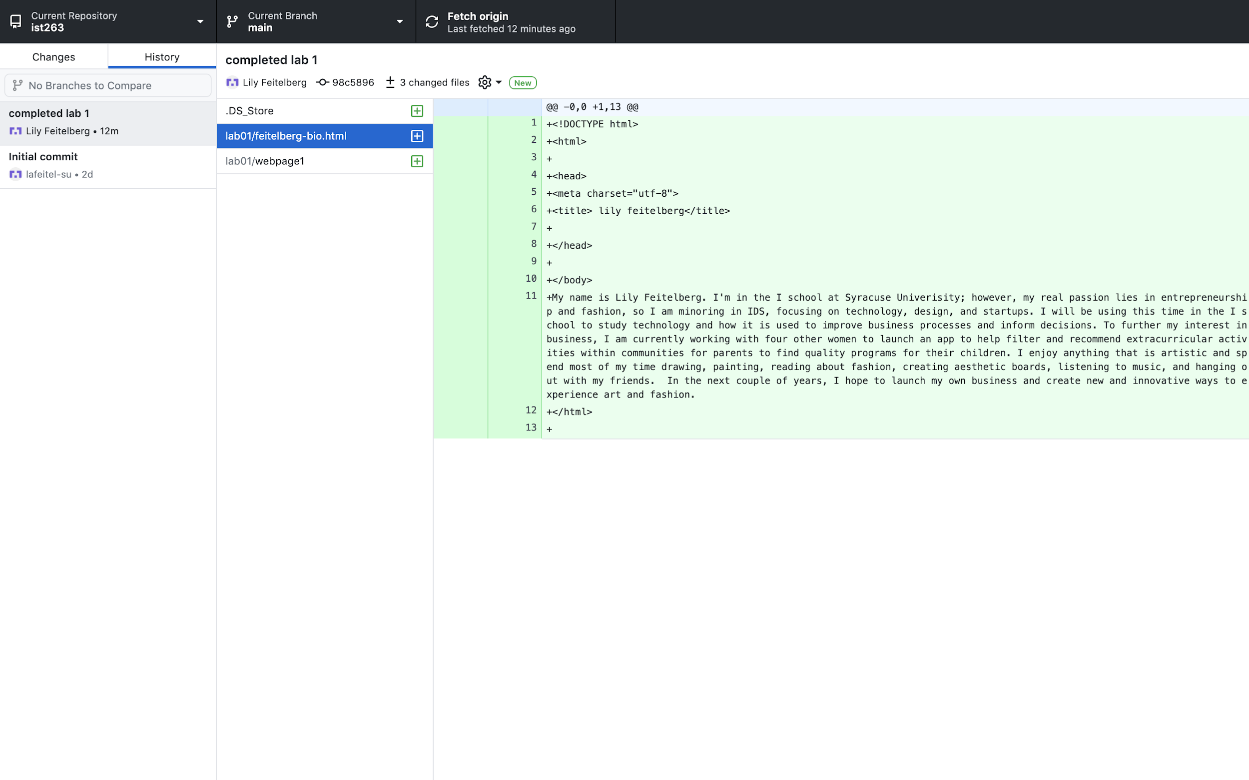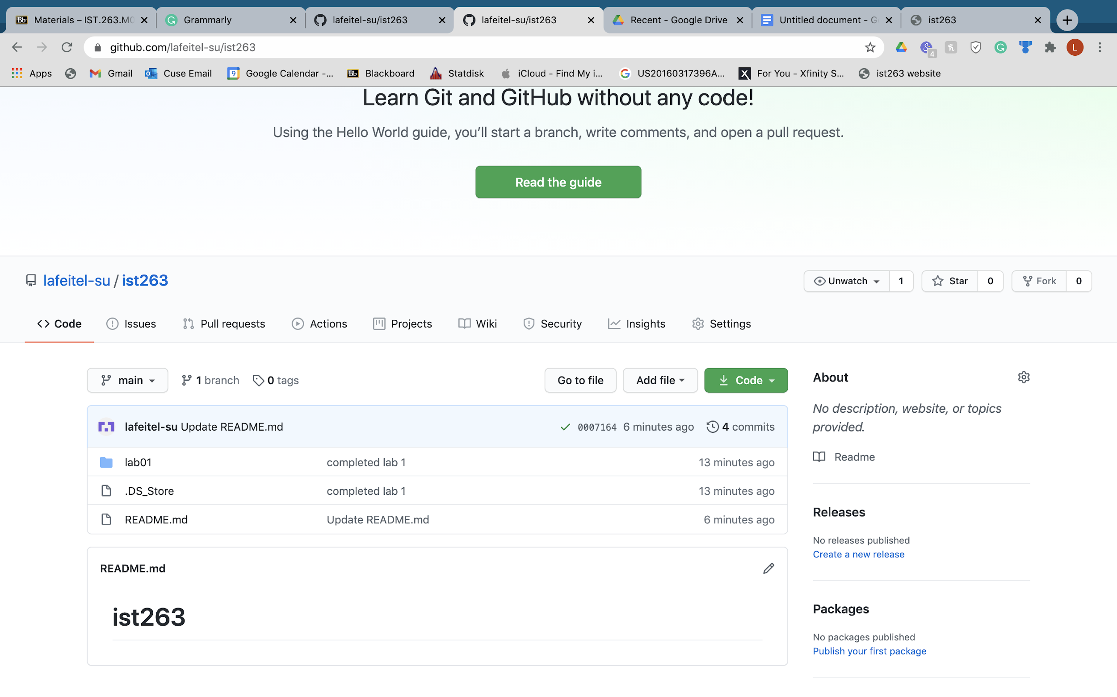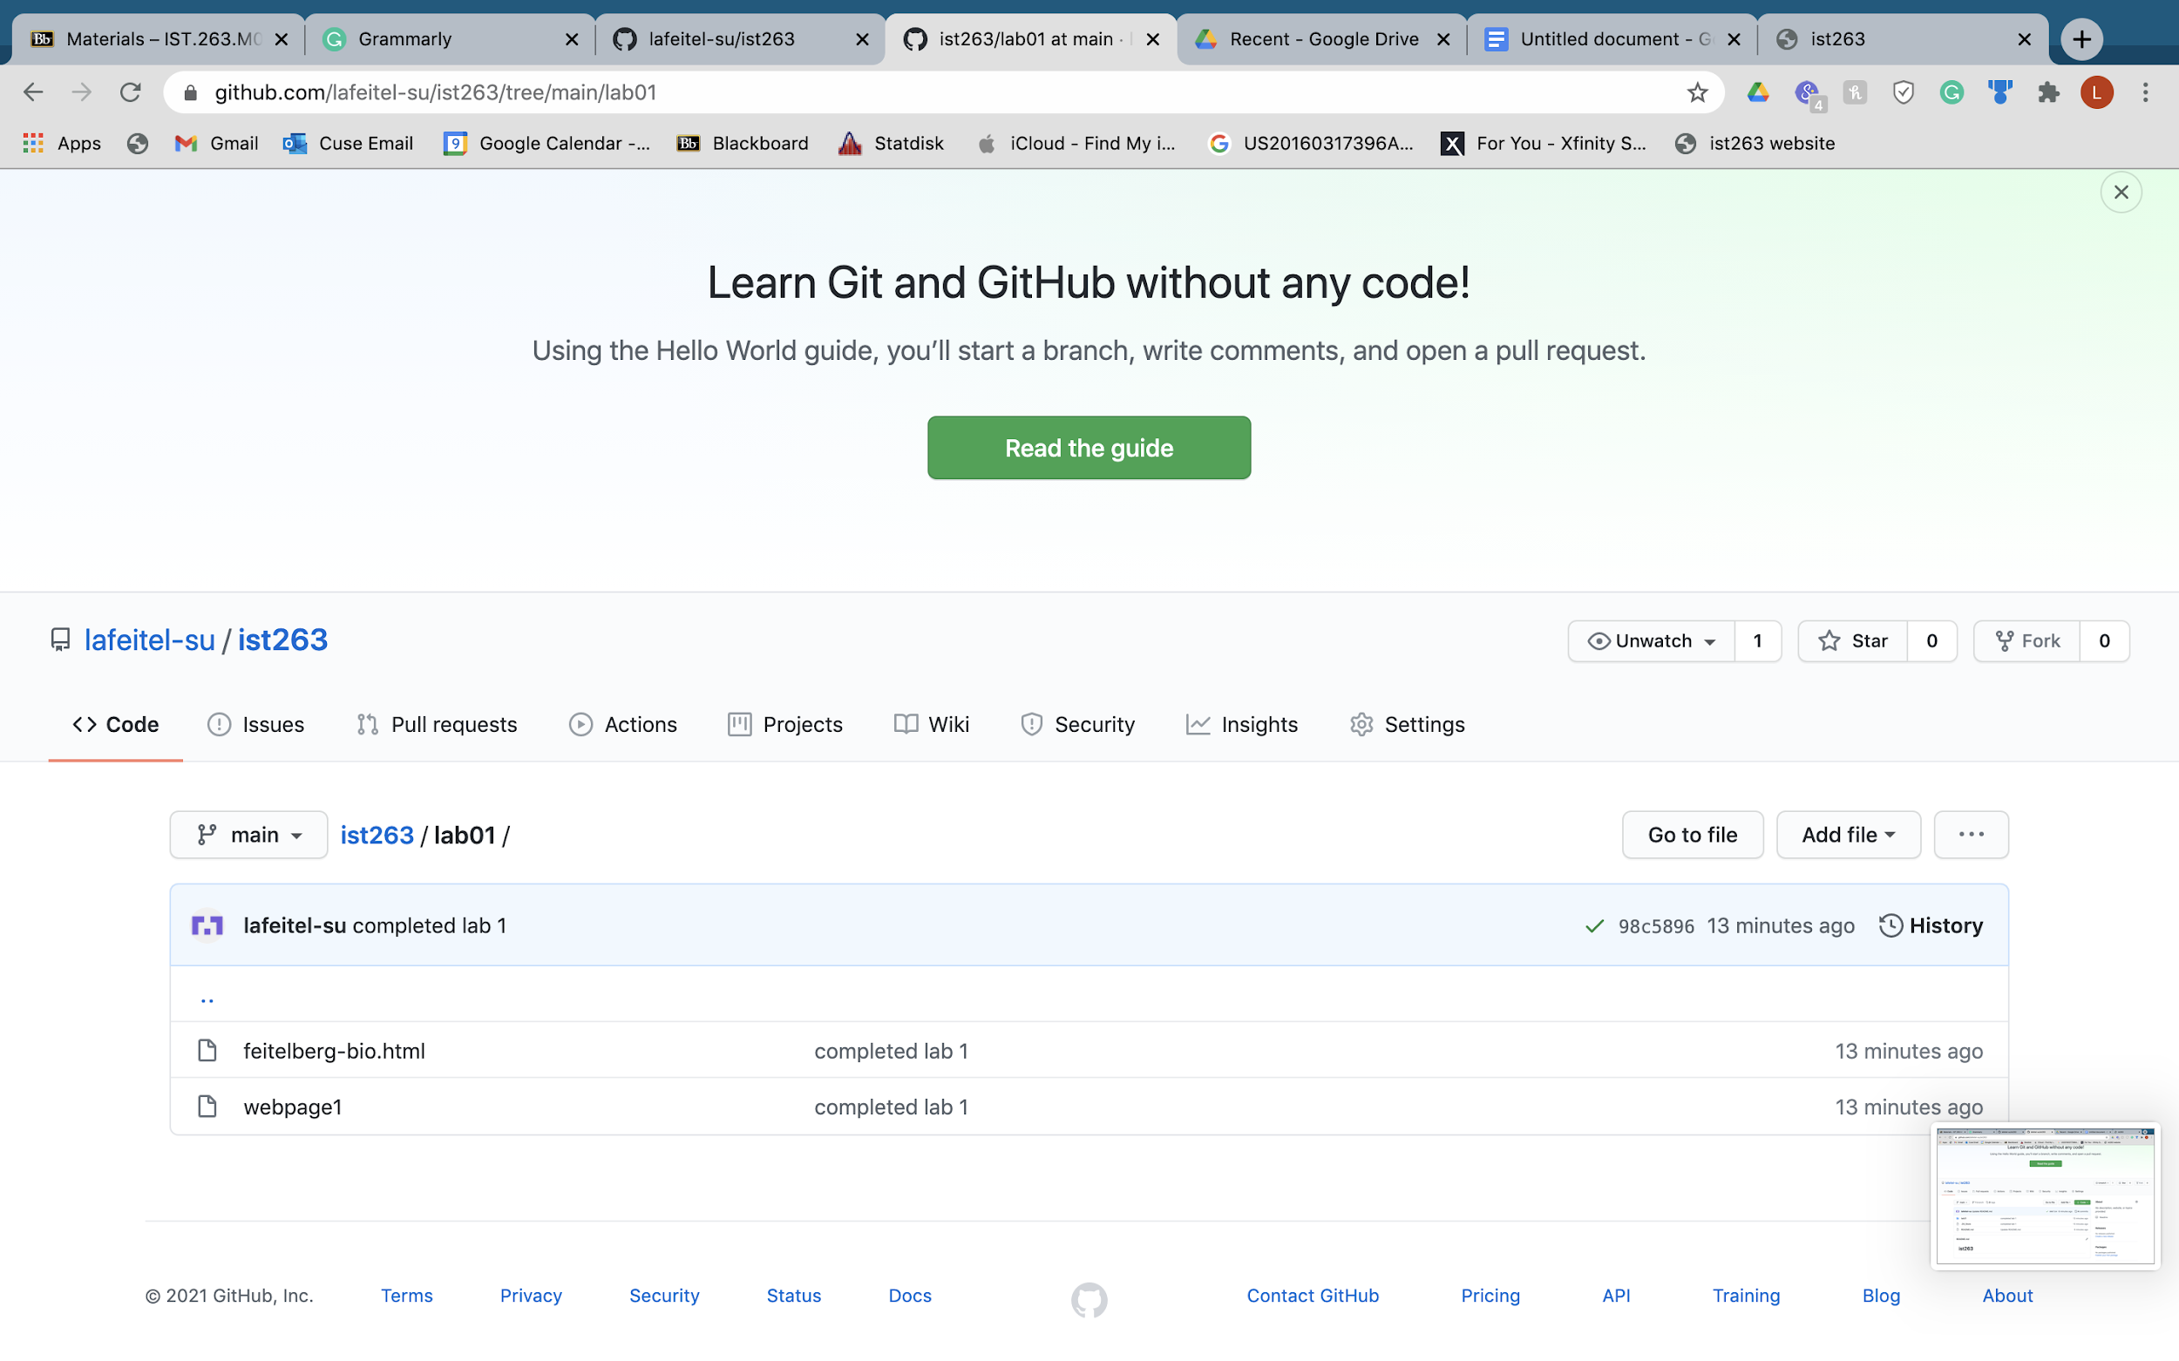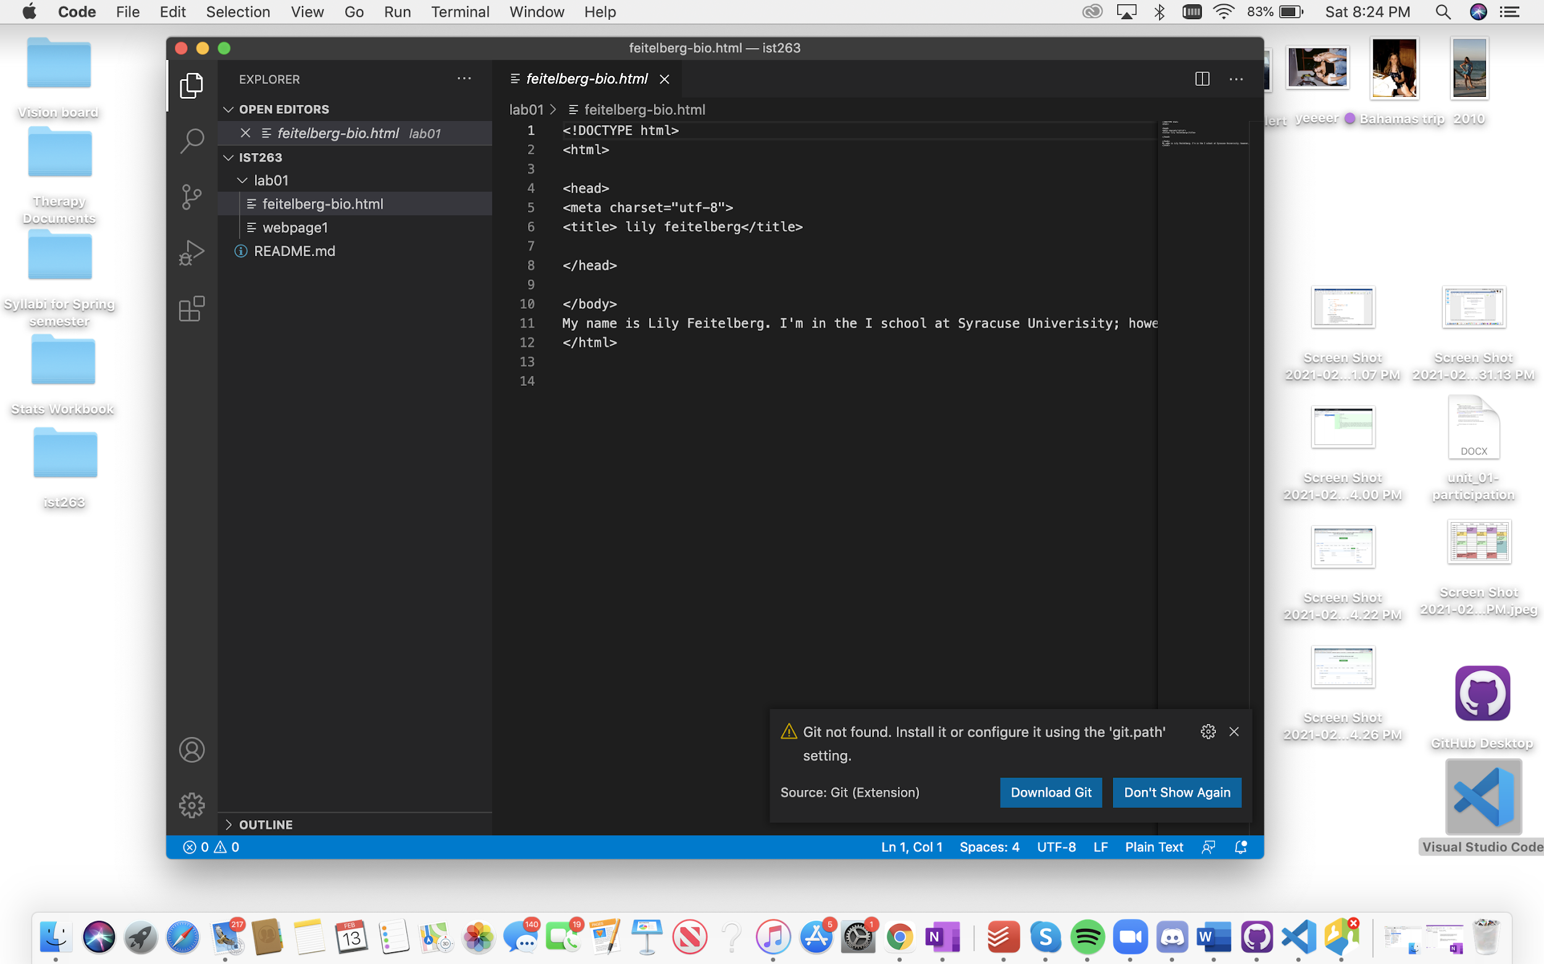

2. Submit answers to the following:

a. What questions did you have about the lab?

I followed all of the steps but I am not understanding how the code did not transfer so when I go to the link it hasn't processed.

b. What was the hardest part of the lab?

Figuring out my errors because the applications are new to me and I don't exactly know how to maneuver.

c. Rate your comfort level with this week's.

1 ==> I can do this on my own and explain how to do it.

2 ==> I can do this on my own without any help.

**3 ==> I can do this with help or guidance from others.**

If you choose this level, please indicate HOW this person helped you.

4 ==> I don't understand this at all yet and need extra help.